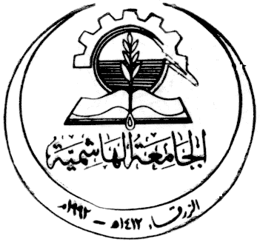 | Hashemite University  College of Engineering  Department of Mechatronics  Microprocessor and Microcontroller 110405424  (3 Credit Hours)
Instructor |  |  |  | Grading info |  |  |  | Class Info
Name |  | Asma Al tamimi |  | First 29/7 |  |  |  | Days
Email: |  | altamimi@hu.edu.jo |  | Second 11/8 |  |  |  | Time
Office: |  | E3434 |  | Proj & Act. |  |  |  | Location
Office hours: |  |  |  | Final
Course
Course Number: |  | 110405322
Prerequisite: |  | Digital Logic and Digital Electronics 110405322
Textbook: |  | Textbook: M Mazidi, R McMinlay, D Causey “PIC microcontroller and Embedded Systems using Assembly  and C for PIC18”, 4th Edition, Prentice Hall.
Course Description (as in the catalog): |  | This course aims to provide the students with the ability to successfully write assembly language programs for the microcontroller through learning the Software architecture, Software development tools, the instruction set and programming techniques
Specific Outcomes of Instruction (Course Outcomes): |  | The student shall be able to:  - Understand Microcontrollers History, Features, Architecture  - Learn how to write Assembly Language Programs  - Use Branch, Call, and I/O Port instructions  - Learn Arithmetic and Logic Instructions, and Programs  - Learn PIC Programming in C
Grading policy |  | Grade Time  - Assignment 20 marks TBD  - Mid exam 40 marks TBD  - Final exam 40 marks TBD
References:
- Microchip Pic18FXX2
- Brey B.B, “The Intel Microprocessors 8086/8088, 80186/80188, 80286, 80486, Pentium and Pentium Pro, Processor Architecture, Programming and Interface”, 5th Edition, Prentice-Hall, Inc.
- Miller G.H, “Microcomputer Engineering”, 2nd Edition, Prentice-Hall, Inc
Major Topics Covered and Schedule in Weeks:
Topic |  |  |  |  | # Weeks |  |  |  | # Contact hours
- The PIC Microcontrollers: History and Features |  |  |  |  | 1 |  |  |  | 3
- PIC Architecture & Assembly Language Programming |  |  |  |  | 2,3 |  |  |  | 6
- Branch, Call, and Time Delay Loop |  |  |  |  | 4,5,6 |  |  |  | 9
- PIC I/O Port Programming |  |  |  |  | 7,8 |  |  |  | 6
- Arithmetic, Logic Instructions, and Programs |  |  |  |  | 9.10,11 |  |  |  | 9
- Bank Switching, Table Processing, Macros, and Modules  - BWM, Interrupts, A/D |  |  |  |  | 12,13 |  |  |  | 6
 |  |  |  |  | 14,15 |  |  |  | 6
Total |  |  |  |  | 15 |  |  |  | 45

